F21DV - Data Visualization and Analytics

**Coursework Lab 4**

**Due on Friday 04 Apr 2022**

**Submitted By: Dayanandan Natarajan**

**Demonstrated to: Benjamin Kenwright**

**Demonstration on: 04-Apr-2022 (Online via Teams)**

**School of Mathematical and Computer Sciences**

**Heriot-Watt University**

Table of Contents

Overview 3

Part 1. Dataset 4

Part 2. Visualization Diagrams 5

1: Sunburst diagram. 7

2: Line chart. 8

3: Bar chart. 10

# Overview

The purpose of this course work is to demonstrate dynamic and interactive visualization concepts using HTML, CSS, Javascript and D3 V 7.3.0.

The selected data is projected on the page using sunburst, line and bar charts. The data is loaded from a CSV file and then formatted to JSON for internal use.

# Part 1. Dataset

The world population data is used in this course work. The same data can be downloaded from,

<https://population.un.org/wpp/Download/Standard/CSV/>

<https://population.un.org/wpp/Download/Files/1_Indicators%20(Standard)/CSV_FILES/WPP2019_TotalPopulationBySex.csv>

Past population data from 1950 – 2020 and future projected data for 2020-2100 is used.

WORLD.csv – The file contains region, sub region info which is used to draw sunburst.

Fertility.csv – Projected fertility rate data of all the countries from 2020 until 2100.

Mortality.csv - Projected mortality rate data of all the countries from 2020 until 2100.

Population.csv – Past population data of all the countries from 1950 until 2020.

Estimates.csv - Projected population data of all the countries from 2020 until 2100.

# Part 2. Visualization Diagrams

The visualization includes, sunburst, line and bar chart. The sunburst diagram shows all the regions, sub regions and countries, by hovering over the country or the region, the past and projected information can be seen on the page. The line chart is the comparison of projected population, fertility and mortality rate. By selecting or click over a country or region in the sunburst diagram, the comparison chart can be seen. The two bar charts display the past and projected population with top 12 countries.

Code:

HTML : Lab4.html

Javascript : main.js, drawsun.js, drawline1.js, bardata.js, drawbar1.js & drawbar2.js

CSS : sunburst.css

Data files : WORLD.csv, Fertility.csv, Mortality.csv, Population.csv & Estimates.csv

Output:

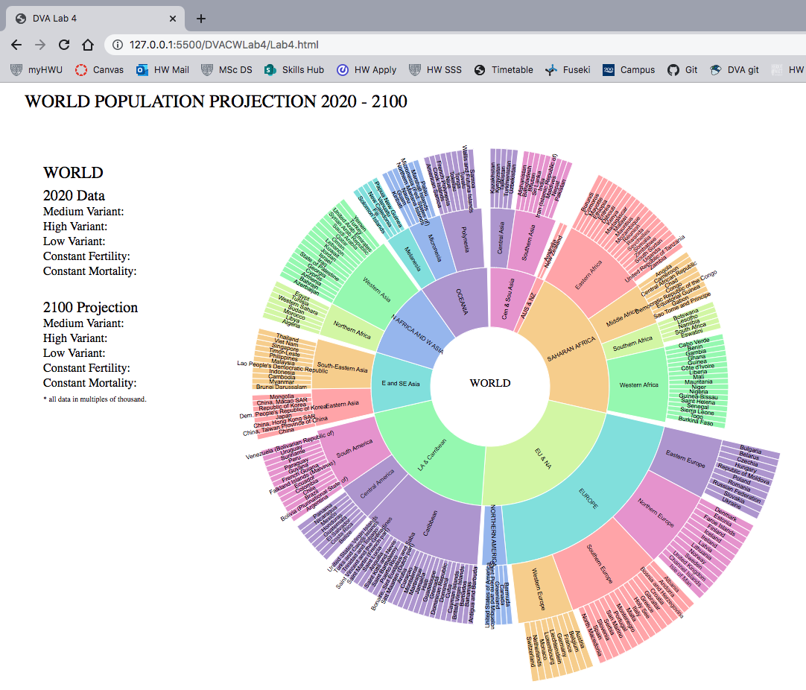

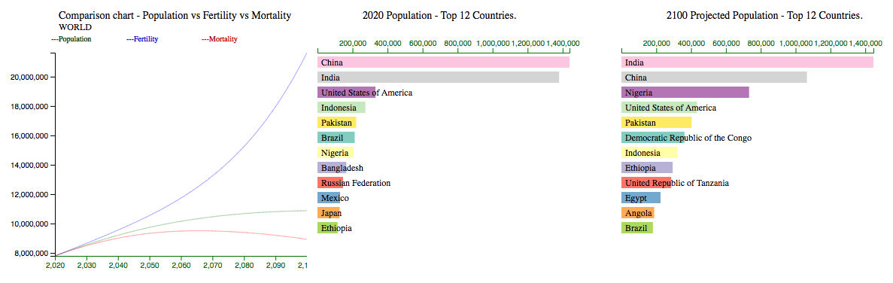

### 1: Sunburst diagram.

The sunburst diagram shows all the regions, sub regions and countries, by hovering over the country or the region, the past and projected information can be seen on the page. The CSV file is loaded and reformatted in to a JSON file based on the hierarchy of regions, sub regions and countries. The created JSON file is used as an input to the sunburst diagram. The arc is created with the hierarchy available in the JSON file, with regions as inner circle, sub regions as middle circle and countries as outer circle.

Mouseover function is added to the diagram to display the past and future data on the page when the mouse is hovered over a region, sub region or country.

Click event is also added to the diagram, on click of a region or sub-region or country, their corresponding comparison line chart is drawn.

Code:

HTML : Lab4.html

Javascript : main.js, drawsun.js

Data files : WORLD.csv

Output:

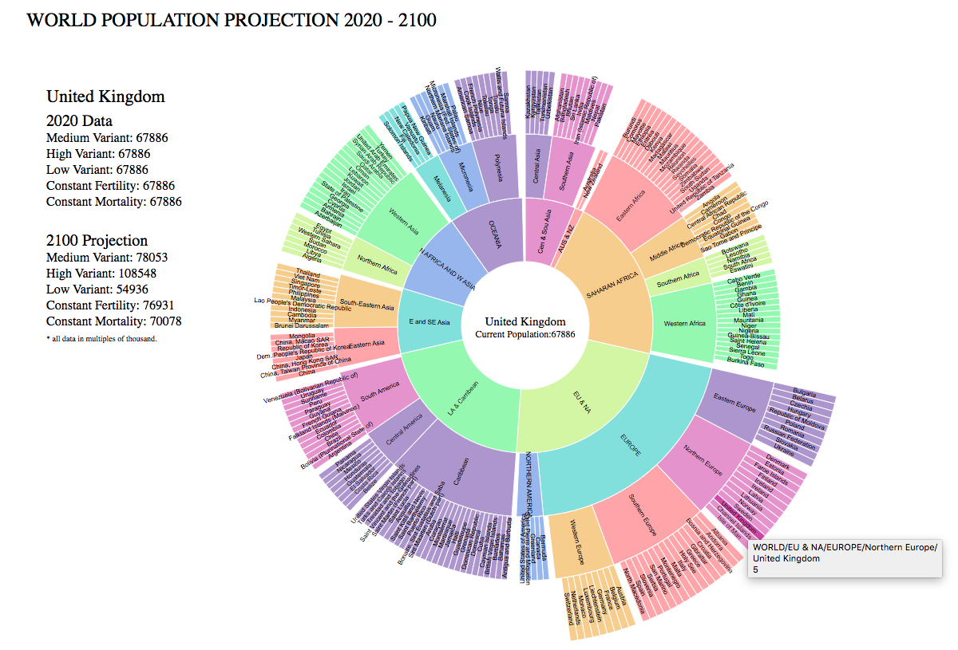

### 2: Line chart.

The initial line chart is drawn with the World data, three lines are drawn to show the growth of population, fertility and mortality from 2020 until 2100. The click event on sunburst diagram will change the selected region/sub region/country data in the line chart.

Code:

HTML : Lab4.html

Javascript : main.js, drawsun.js, drawline1.js

Data files : WORLD.csv, Fertility.csv, Mortality.csv & Estimates.csv

Output:

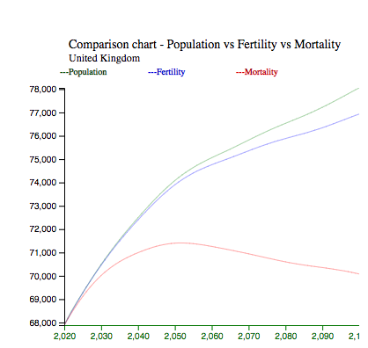

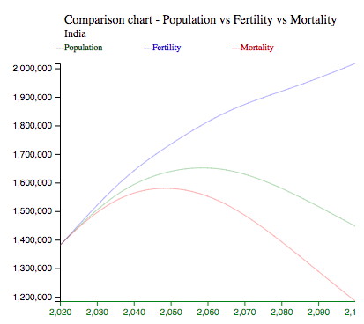

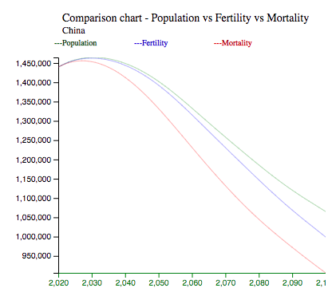

### 3: Bar chart.

The two bar charts are drawn based on the data from Estimates.csv and Population.csv file. Bar chart one is drawn based on the past population as on 2020 and the top 12 countries were listed with the bar width directly proportional to population. Bar chart two is drawn based on the projected population as on 2100 and the top 12 countries were listed with the bar width directly proportional to population.

Code:

HTML : Lab4.html

Javascript : bardata.js, drawbar1.js & drawbar2.js

Data files : Population.csv & Estimates.csv

Output:

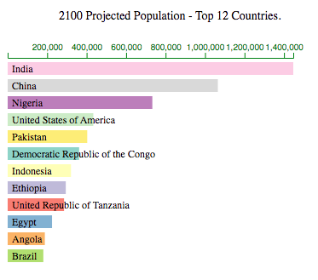

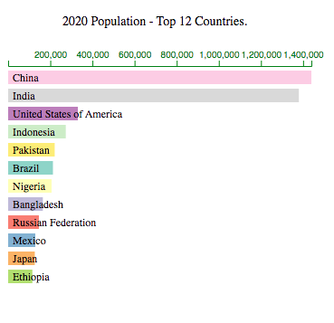

END OF REPORT,

THANK YOU.